A System Dynamics Model of the Refugee Crisis
Part 7 – Unintended Consequences and the Need for Further Work

Unintended Consequences

In this part, we will discuss some of the potential unintended consequences that are contained in the System Dynamics model and some of the potential unintended consequences that still need to be modelled.

We have seen the potential of System Dynamics modelling to provide insight into the complex problem of the refugee crisis. We have found a potential positive unintended consequence; namely, if we can minimize the deaths from violence, starvation and disease, and improve the immigration process and create jobs through economic development, this will also resolve the problem of deaths caused by unconventional border crossings. However, it is not clear how the aid nations could influence some of the variables which would need to be modified to make these positive changes. On the other hand, we have seen that the direction of the changes have been indicated even if the aid nations can not arrive at the ideal values.

There are a number of other possibly negative unintended consequences that are readily apparent from the System Dynamics model's balancing feedback loops. For example, the investment in peacekeeping and diplomacy might reduce the level of violence in the short-term but once the level of violence is reduced, there will be less pressure on the aid nations to invest in further peacekeeping and diplomacy. Since violence is assumed to increase without interventions, the level of violence will start to rise again in the longer-term once the pressure is off the aid countries to provide peacekeeping and diplomatic effort. This will cause an oscillation in violence levels decreasing and increasing indefinitely without ever completely resolving the violence and the refugee problem in the long-term.

Similarly, investment in food aid may reduce the number of people without food in the short-term but then there will be less pressure on the aid nations to provide further food aid. Once the violence level increases again, the ability to produce food in the country will be reduced causing the number of people without food to increase again. This would create another oscillation effect with food aid in the long-term.

All of the balancing feedback loops in the model would produce the same type of oscillating result.

When this chapter was reviewed by a refugee from Yemen, he noted a number of negative unintended consequences that were not modelled. First, there is the potential of food aid being abused. He has seen refugees lie about the size of their families to obtain more food than their family needs and then take the extra food aid to the market and sell it to obtain extra cash. This has the unintended consequence undermining the producers of food in the country and ruining their ability to make a living by providing food for their fellow citizens thereby creating long-term problems of food insecurity.

Figure XX shows an influence diagram of the unintended consequences of food aid. We can start with the food needed. The more food needed, the more potential money that can be earned by refugees selling food aid. The more potential money earned, the higher the stated need for food. The higher the stated need for food, the more food aid delivered to a family of refugees. The more food aid delivered to a family of refugees, the larger the gap between the food aid delivered and the food needed by the family. The larger the gap between the food aid delivered and the food needed by the family, the more food is available to sell in the market and the more money earned by the refugee family. However, the more food in the market sold by refugees, the less food sold in the market by farmers. The less food sold by farmers, the less money earned by farmers and the less farmers' profit. The less farmers' profit, the less food produced and the less farmers' food sold in the market. This vicious cycle repeats until the farmers are driven out the market by refugee families overstating their food need and selling the extra food which will make the refugees completely dependent on food aid to meet their true needs in the long-term.

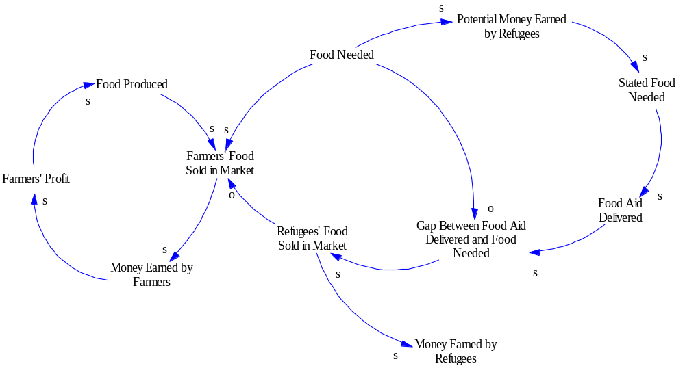

Model of Unintended Consequences of Food Aid

Another negative unintended consequence noted, that was not modelled, was caused by the payment of wages to peacekeepers in the country. Peacekeepers from many African nations would get paid at a much higher rate in the peacekeeping role than they would be paid as soldiers in their own country. Therefore, it may not be in their best interest to resolve the violence quickly. They may even instigate more violence to keep getting paid as peacekeepers.

Figure XX shows an influence diagram of the unintended consequences of payments to peacekeepers. We can begin from the desired compensation. The desired compensation and the compensation are tied to the compensation gap in the logical way. The compensation gap is connected to the effort to reduce violence by the peacekeepers in such a way that if the compensation gap gets larger, the effort to reduce the level of violence gets smaller and vice versa. The more effort to reduce the violence, the lower the level of violence and the less need for peacekeepers. The less need for peacekeepers, the fewer peacekeepers in the country and the less compensation. Therefore, reducing the level of violence increases the compensation gap and reduces the effort of the peacekeepers and in this way, we can see that the peacekeepers have limited incentive to reduce the level of violence.

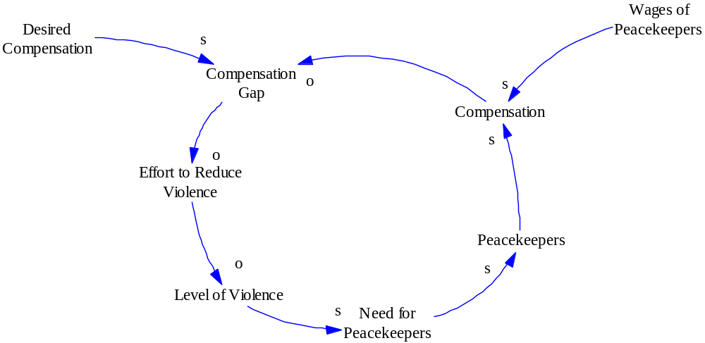

Model of Unintended Consequences Involving Peacekeeping

These negative unintended consequences are the result of second-order effects that were not directly modelled in our original System Dynamics model. They indicate the need for more work on this model to ensure the desired results are obtained and sustained.

Private discussion Ivan Taylor and Ali Sheikh, 28 Oct 2017.

